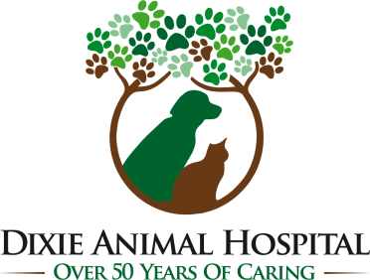
14701 South Dixie Highway
Miami, Florida 33176
Ph. (305) 238-5161
Fax (305) 238-9297
e-mail: dixieanimal@bellsouth.net
Website: www.dixieanimalhospital.com

WELCOME

Thank you for giving us the opportunity to care for your pet(s).
So that we may become better acquainted, please complete the following.

OWNER INFORMATION: Date: ___________

Name: Ms. / Mrs. / Mr. / Dr.__________________________________________________

Address: __________________________ City/State/Zip: __________________________

Driver’s License: ____________________________ SS# (Optional): _______________________

CELL Phone:__________________________ Home Phone:_________________________

e-mail:________________________________________________________________

Place of Employment:___________________________ Work Phone: ___________________

Spouse/Significant Other: ________________________ Cell Phone:____________________

Place of Employment:___________________________ Work Phone:___________________

How did you become aware of our clinic? ○Drove By ○Previous Client ○Social Media ○Google ○Yelp
○Manta ○Yellow Pages ○Personal Recommendation: _________________________________
(Whom may we thank?)

ALL FEES ARE DUE AT THE TIME SERVICES ARE RENDERED

For your convenience, we accept Visa, MasterCard, Discover, American Express, CareCredit, Cash and Personal Checks. The undersigned agrees, as guarantor, that in consideration of the services to be rendered, he/she hereby individually obligates himself/herself to pay the account. I also understand that all fees are due at the time services are rendered unless an exception is made by the hospital director. Should the account be referred to an attorney for collection, I authorize attorney to obtain my credit report, and the undersigned shall pay reasonable attorney’s fees and collection expenses. Any fees not paid in full within 30 days of services rendered accrue interest at 1.5% per month until the balance is paid.
To prevent the spread of infectious disease and parasites, all in-patients, out-patients, boarding pets and grooming pets MUST be current on ALL vaccinations and be free of parasites unless otherwise approved by one of the veterinarians. The undersigned agrees, as guarantor, that the patient below is current on ALL vaccinations or is to be required to have vaccinations administered by a veterinarian to avoid spread of infectious diseases and parasites.

Signature _________________________________________________ Date: _______________________

Pet Name:_____________________ Age or DOB:__________________________ ○Dog ○Cat

Breed: ________________________ Color(s): ______________________ Sex: ○Male ○Female

Is your pet spayed or neutered? ○Yes ○No • Is your pet up to date with their vaccinations? ○Yes ○No

Does your pet have a microchip? ○Yes ○No • Microchip #: ________________________________

Medical Conditions/Concerns: ______________________________________________________

______________________________________________________________________________________________________________________

Previous Veterinarian/Clinic Name: __________________________________________________

Michael J. Pegelow, D.V.M • Lara Sparks, D.V.M. TURN OVER
Date: ___________
Photography Release Form
I authorize Dixie Animal Hospital and the employees of Dixie Animal Hospital to use my pet’s name, likeness, and any images taken with digital cameras or cellular devices, without charge, for promotional purposes in social media, advertising, news media, video publications, blog publications, web publications, or any other formats.

Name:
Signature:
Pet’s Name:

